Docker Task-03
- Create a image from running container.
Step 1: Check the existing container
You should see my-nginx
To use the existing container, start it:
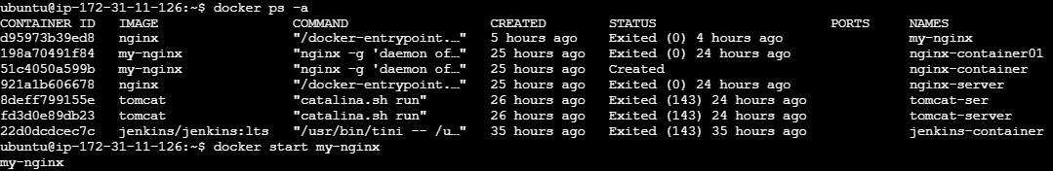

Step 2 : Create an image from the running container
Use docker commit: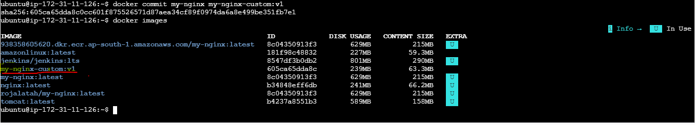
2. Copy image from local machine to docker server and load the image.
Step 1: Save the Docker image on your local machine
Save my-nginx-custom:v1 image as a .tar file and check the file
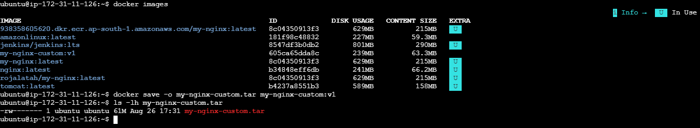
Step 2: Copy the image to the Docker server
You should now be back at your Windows PowerShell:
PS C:\Users\Dell>
You need the PEM key that allows you to SSH into Server 1 (172.31.11.126).
If that key path is : C:\Users\Dell\Downloads\Europe.s.pemand Server 1 has a reachable public IP, run from Windows powershell:
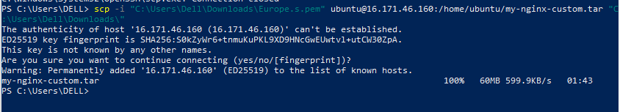
Step 4: SSH into Ubuntu server and load the docker image:
Now connect back to ubuntu server and check whether the Docker image .tar file exists
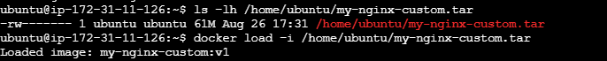

Step 6 — Verify the loaded image
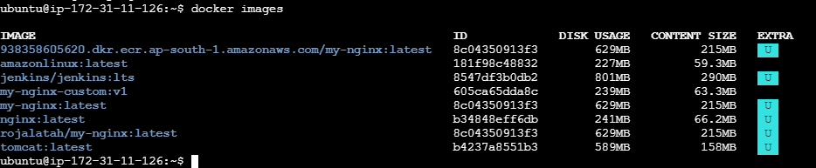

1. Create a project directory
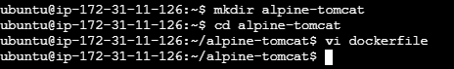
2. Create the Dockerfile
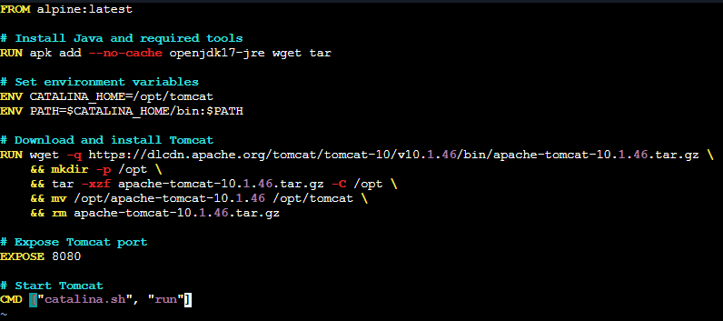
3. Build the Docker image
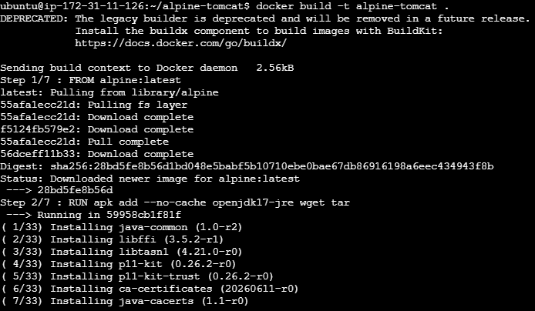

4. Verify the docker images
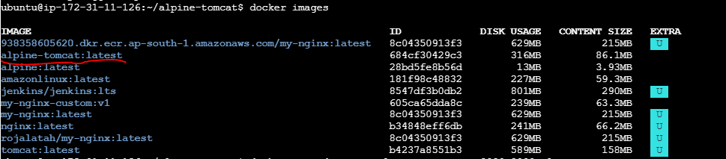
5. Run the container and verify the conatiner
6. Access it on the browser:
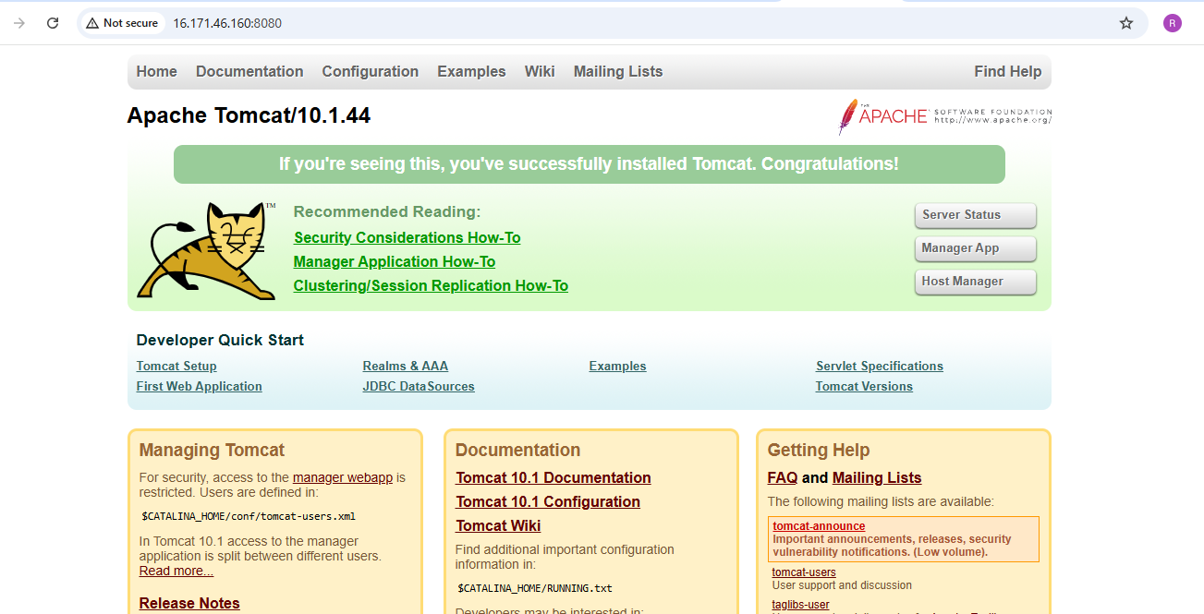

6. Verify inside the container
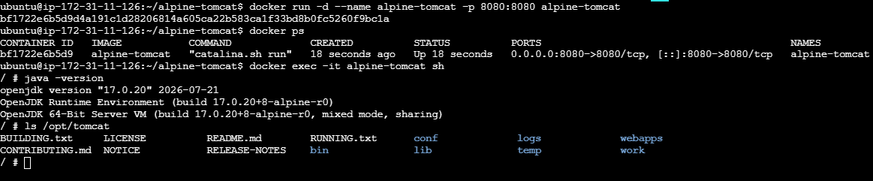
4. Create single stage and multi stage docker file using this source code:https://github.com/betawins/multi-stage-example.git

Step 1. Clone the source code
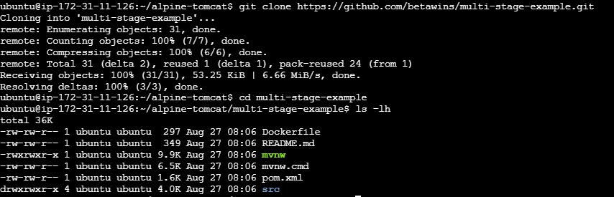
Step 2. Single-stage Dockerfile
Create Vi file
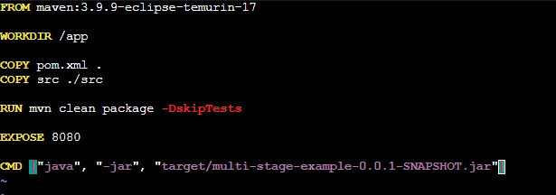

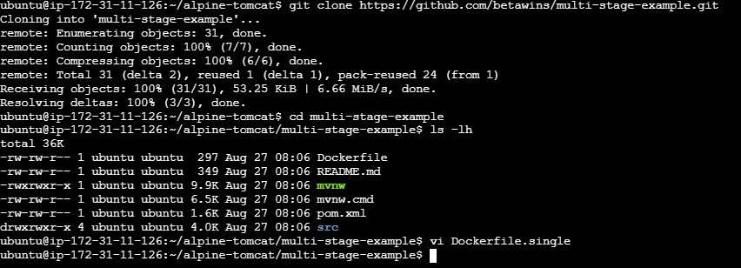

Step 3: Build the single-stage image
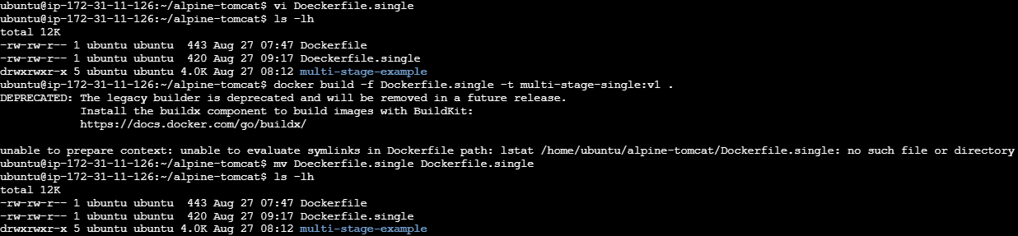
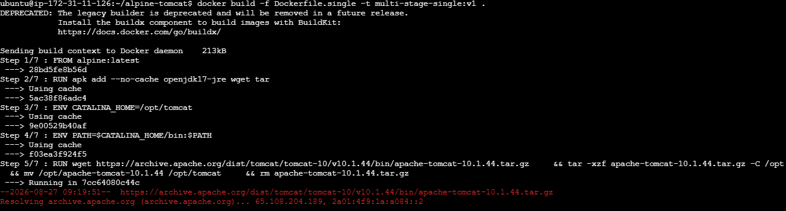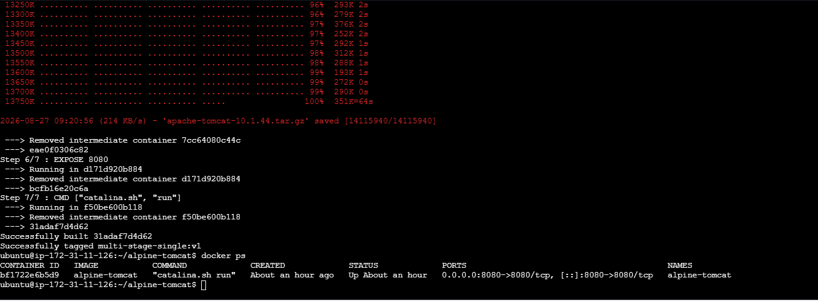

Step 4: Access it in browser:
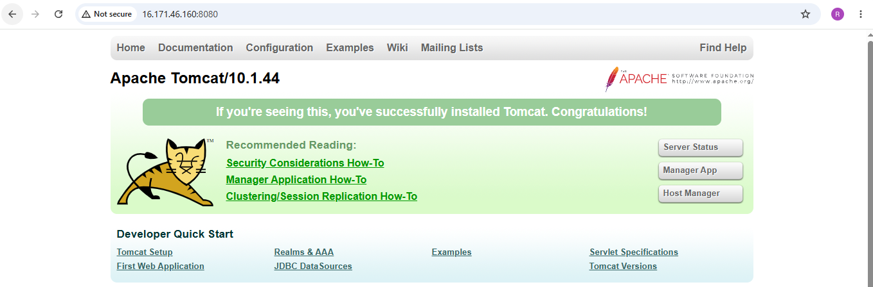

3. Multi-stage Dockerfile
Now create Dockerfile.multi using vi
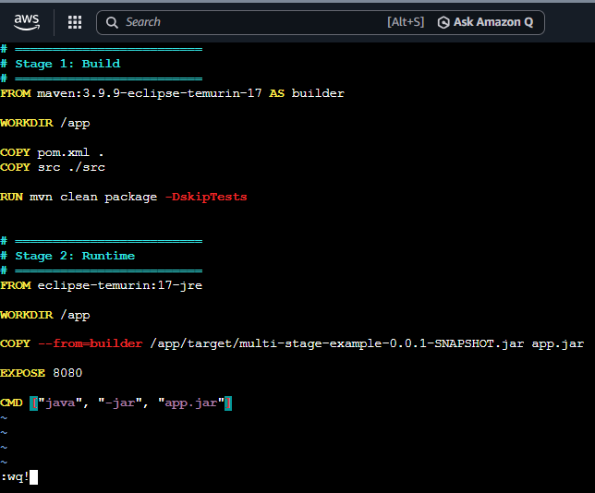
4. Build Multi stage Dockerfile:
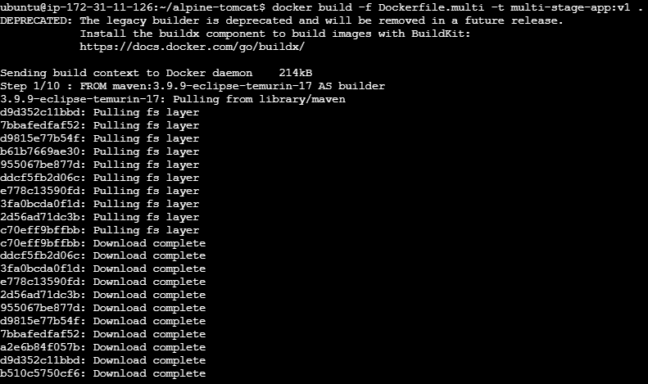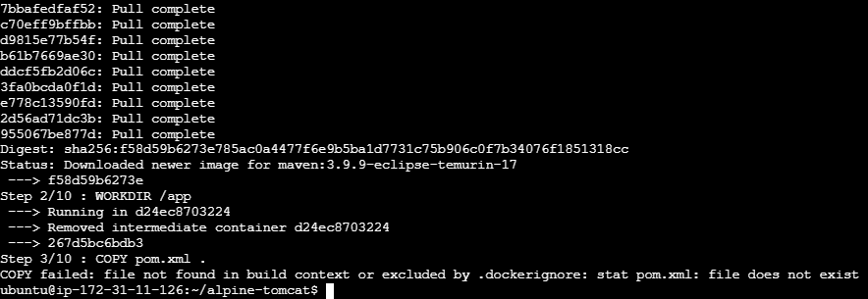
Create and start a Docker container from the image multi-stage-app:v1, runs it in the background, gives it a name, and maps port 8084 on your server to port 8080 inside the container
Also verify the container.
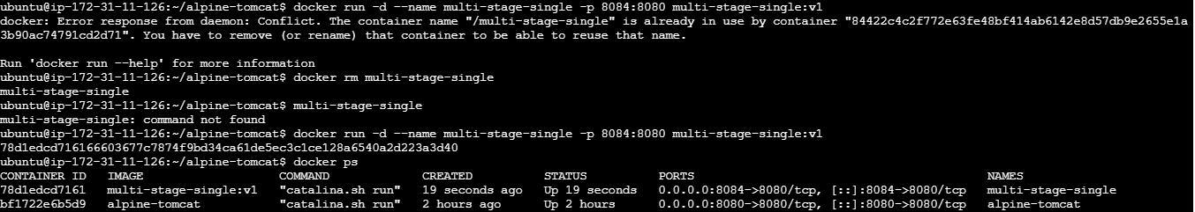
Access it on browser:
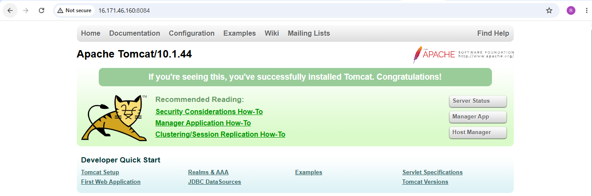
5. Install docker compose and execute sample application.
Step 1: Verify Docker and Check Docker Compose
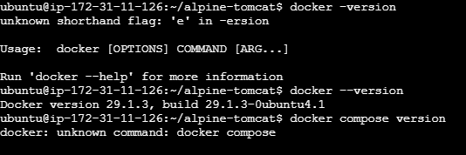

Step 2: Check Docker Compose
Check docker compose version
If it is not installed:
sudo apt update
sudo apt install -y docker-compose-plugin
Verify again: docker compose version

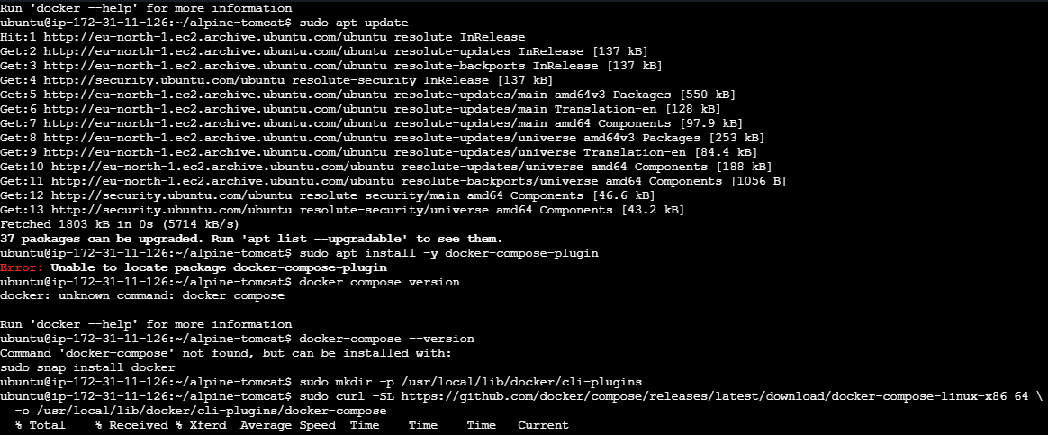
Step 3: Clone the sample application
git clone https://github.com/betawins/multi-stage-example.git is already cloned
Check the files:
ls -la

Step 4: Create compose.yaml using Vi editor
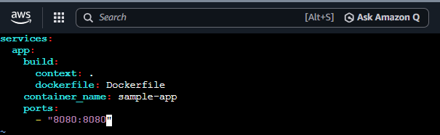

Step 5: Build and start the application
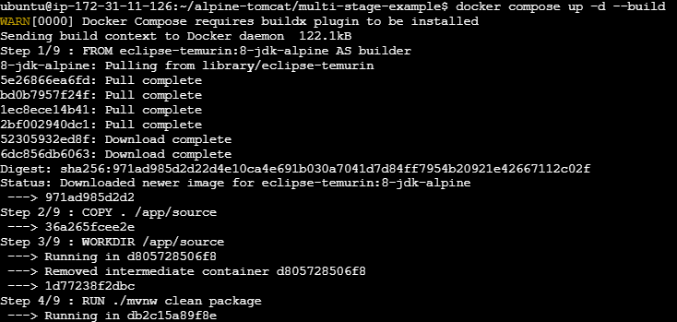
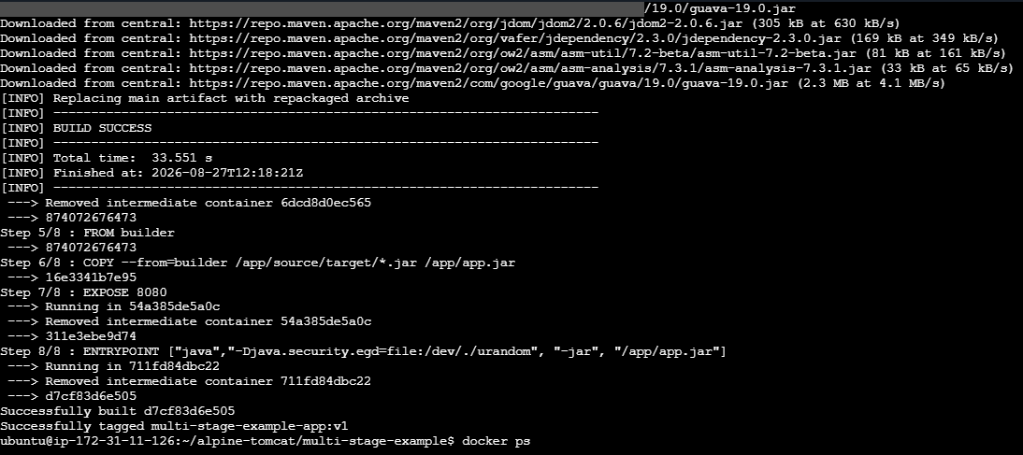
Verified the container :
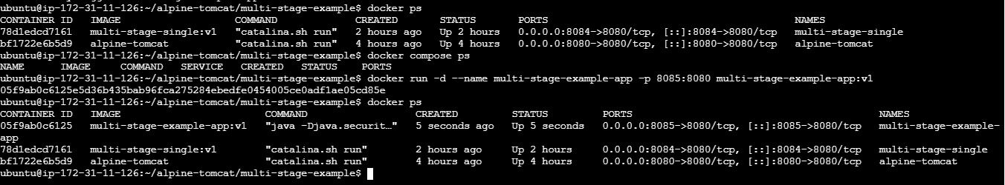
Accessed in the browser:
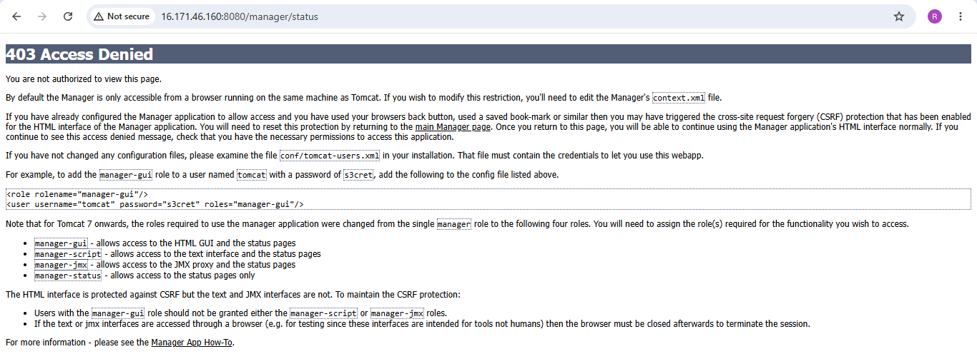

6. Implement solution to scan images when pushed to docker registry.

Step 1: Install Trivy
Updated the packages
Installed wget to install the wget utility on Ubuntu.
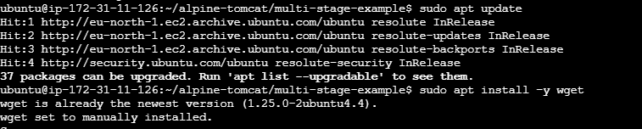
The command used below downloads the public GPG key provided by the Trivy project.
The key is used to verify that packages from the Trivy repository are genuinely signed by the expected publisher.
Then added the official Trivy APT repository to Ubuntu's package sources, to install Trivy using apt.
Updated packages and installed Trivy
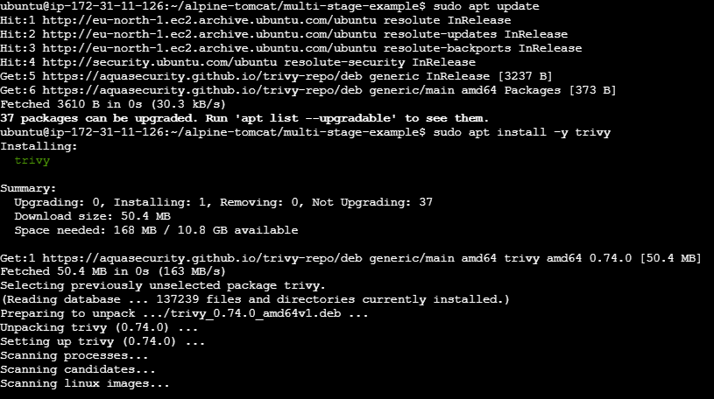
Trivy successfully scanned and gave the following output:
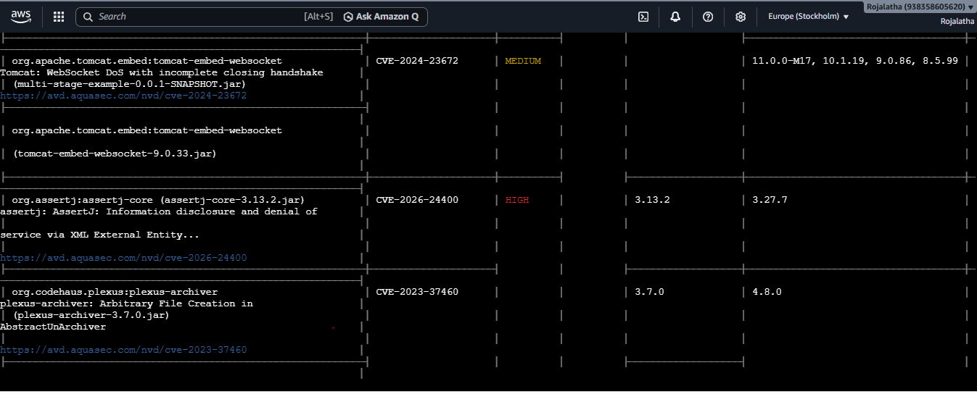
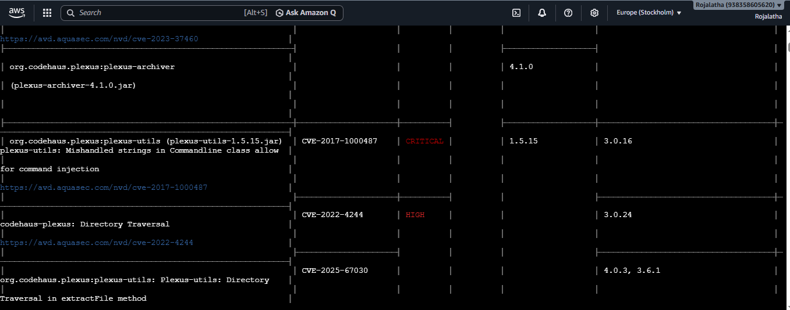
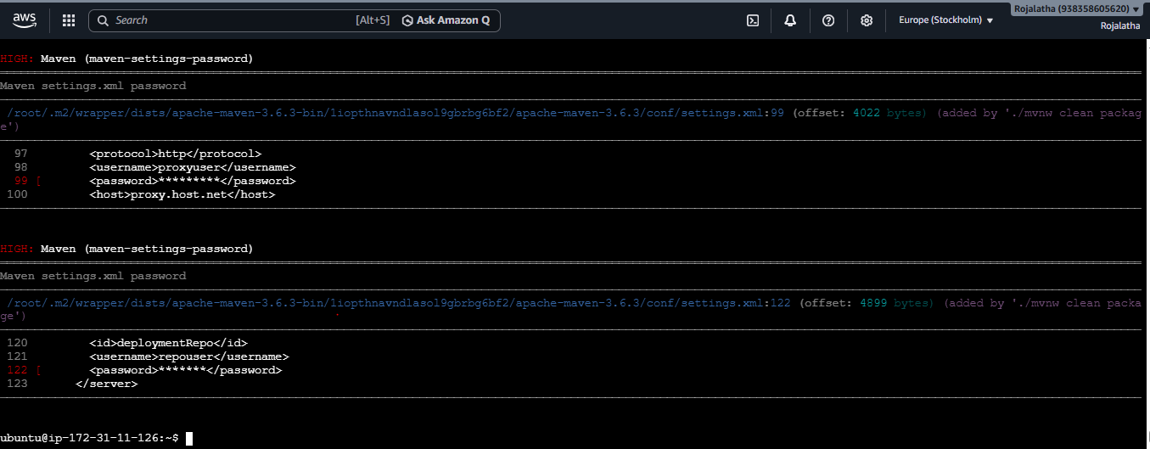

After scan passes, pushed the image to dockerhub:
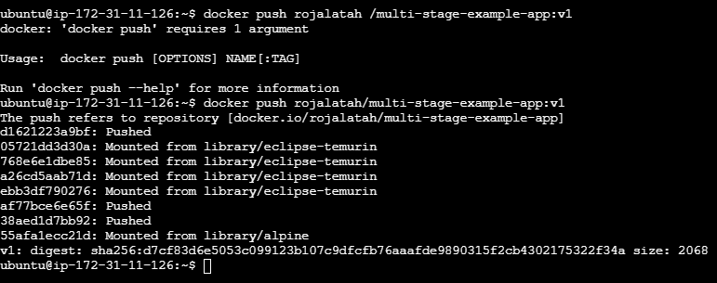
Verified that imaged is pushed to docker-hub:
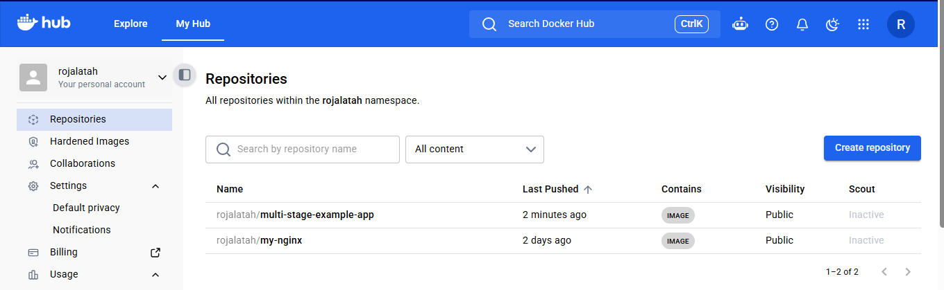
7. Implement solution to scan images when pushed to AWS ECR.

Step 1: Enable image scanning in ECR

Step 2: Push your image
Tag the image and push it to registry
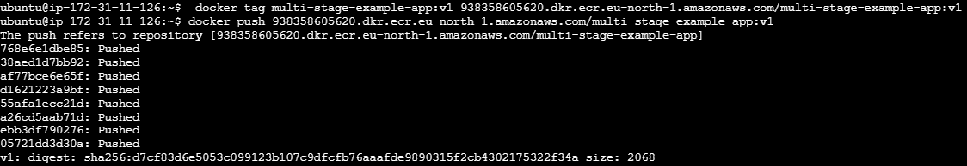
Because scanOnPush=true, ECR automatically starts scanning the image.

Step 3: Check scan results
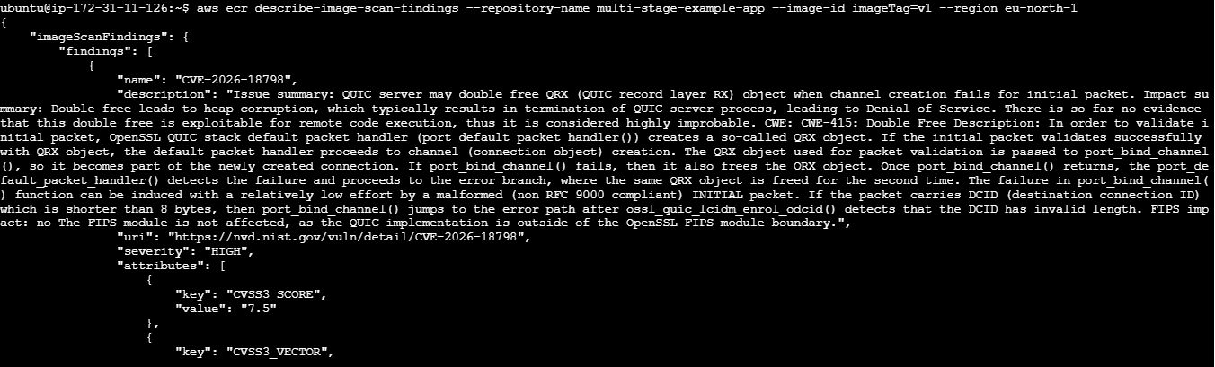
8. Create a Jenkins pipeline to create a docker image and push the image to Docker hub.

Prerequisites
Make sure Jenkins has:
- Docker installed
- Jenkins user has permission to run Docker
- Your application source code contains a Dockerfile
- Docker Hub account
- Docker Hub repository created
Step 1: Add Docker Hub credentials to Jenkins
Go to: Jenkins → Manage Jenkins → Credentials → System → Global credentials → Add Credentials
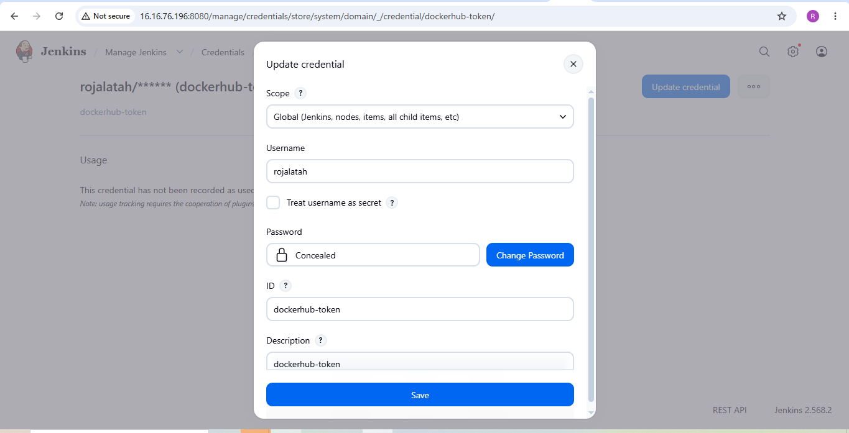

Step 2: Create the Jenkinsfile
Go to: Jenkins → New Item
Enter: Name: pipeline
Select: Pipeline
Click: OK
Scroll down to: Pipeline
Select: Definition: Pipeline script
Then use the Jenkinsfile:
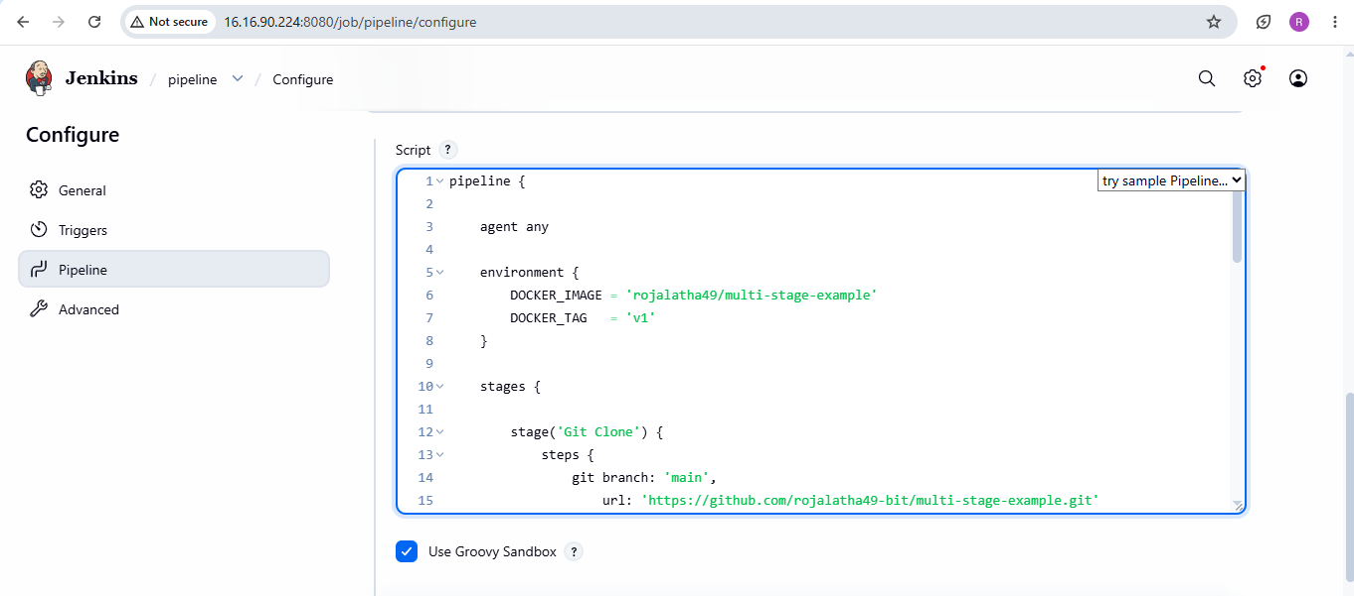
Step 3: Check git status and the commit and push the commits:
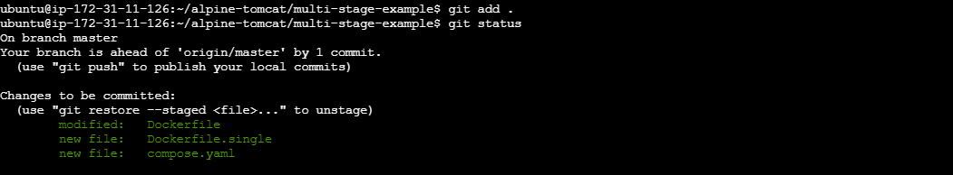
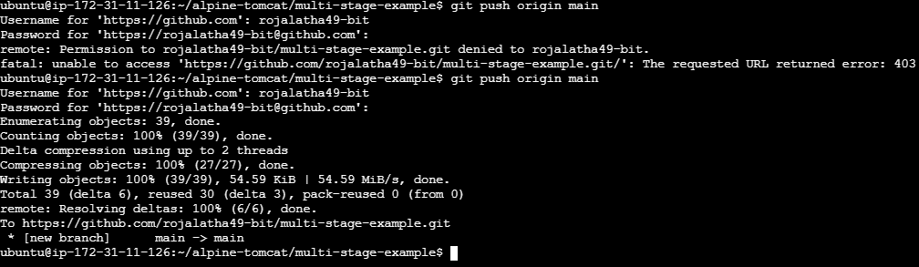
Step 3: Save and Build
Click: Save and click on build now
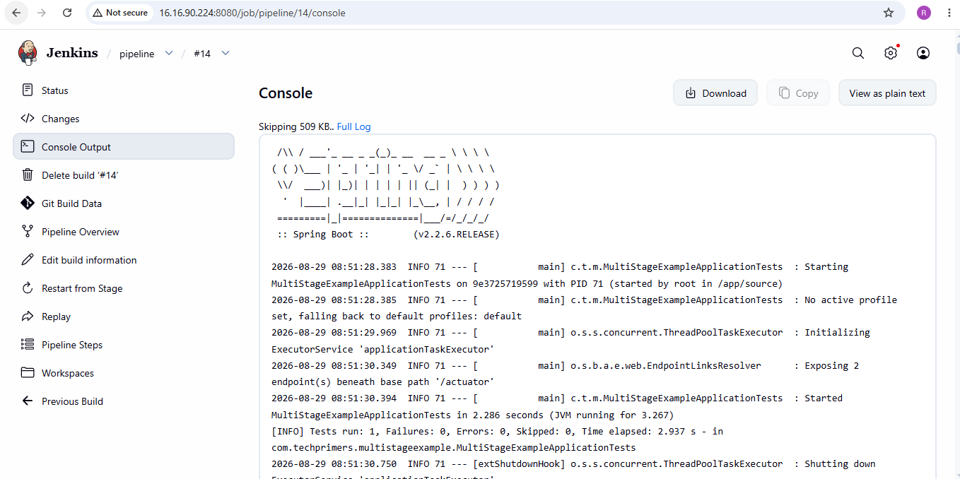
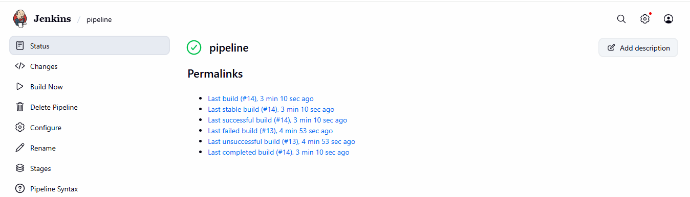

Step 4: Verified in Docker hub –repository

